Workbook 3# Arduino and Hardware section

1. Open this page in laptop not mobile <http://wiki.ros.org/rosserial_arduino/Tutorials>
2. Check ros version with rosversion -d
3. Install ROS Serial using the correct version as below

sudo apt-get install ros-indigo-rosserial-arduino

sudo apt-get install ros-indigo-rosserial

1. If this does not work install from Source with

cd <ws>/src

git clone https://github.com/ros-drivers/rosserial.git

cd <ws>

catkin_make

### Install ros_lib into the Arduino Environment

cd <sketchbook>/libraries

rm -rf ros_lib

rosrun rosserial_arduino make_libraries.py .

Do not miss the . in the last command up

Test if ros_lib is installed by –

Arduino – File – Examples – ros_lib (You should see a ros_lib in examples)

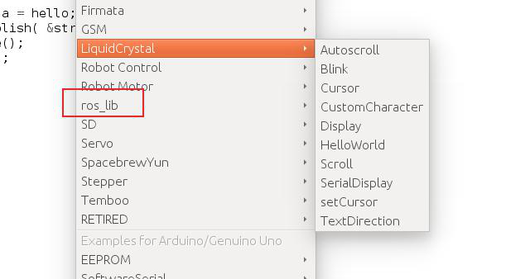

**Arduino with Chatter Talker**

1. Open Arduino through command line else you will not be able to deploy code to MCU
2. 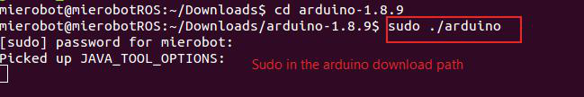
3. Open Arduino – ros serial – Hello World
4. Change port authorization with chmod q+rw /dev/ttyACM0
5. Update with sudo usermod -a -G dialout $mierobot
6. Open this python file with right click gedit as

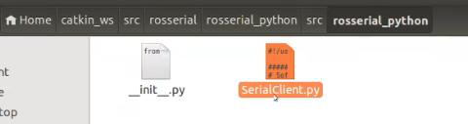

1. Update python file as SerialClient.py (call me if you are not clear)

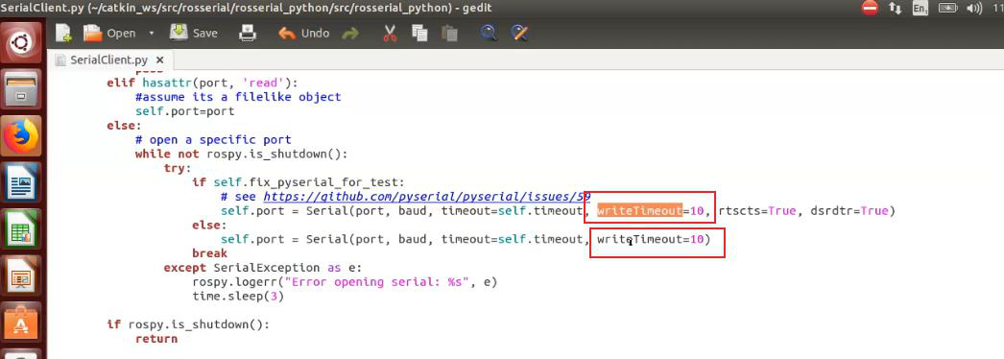

1. Select port and board as Uno and deploy. Make sure your USB detects Arduino as

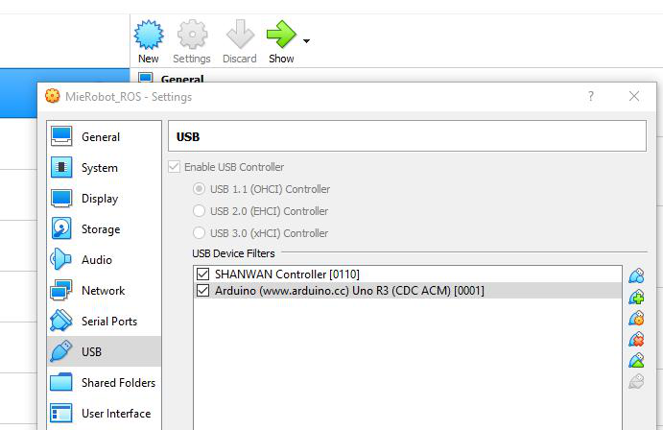

1. Run using as below

roscore

rosrun rosserial_python serial_node.py _port:=/dev/ttyUSB0

rosrun rosserial_arduino serial_node.py _port:=/dev/ttyUSB0

rostopic echo chatter